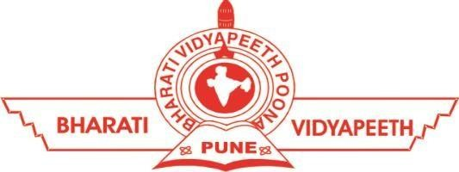

**Bharati Vidyapeeth’s College Of Engineering for Women, Pune – 43**

**Department of Computer Engineering**

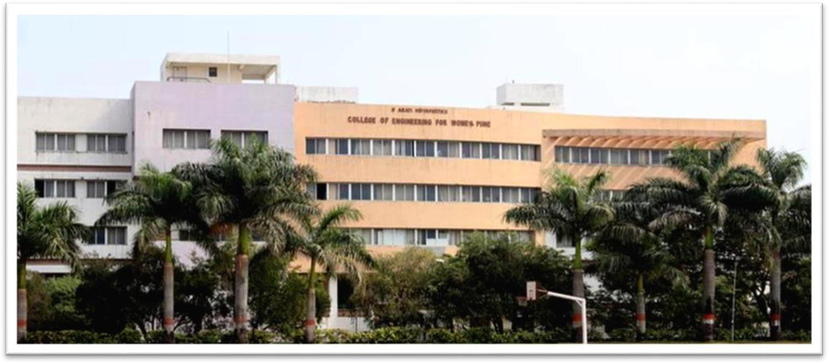

**PROJECT BASED LEARNING**



**Bharati Vidyapeeth’s College Of Engineering for Women, Pune – 43**

**Department of Computer Engineering**

**Project Based Learning Report**

on

**“Sentiment Analysis of Social Media Reviews Using NLP Approach”**

**SUBMITTED BY**

Ms. Mitali Rajesh Chavan (2239)

Ms. Sai Tanaji Nagane (2241)

Ms. Chahal Ohri (2244)

Ms. Khushi Padhar (2245)

Ms. Jagruti Patil (2248)

**Guide: Prof. Shital Pawar**



**Bharati Vidyapeeth’s College Of Engineering for Women, Pune – 43**

**Department of Computer Engineering**

***Certificate of Originality***

***Year:*** *2023* ***Date:***  *30/05/2023*

This is to certify, that the project Sentiment Analysis of Social Media Reviews Using NLP Approach submitted by me is an outcome of my own work. I have duly acknowledged all the sources from which the ideas and extracts have been taken. This project has not been copied from anywhere and all the data has been collected by me.

**Name of Student:** Mitali Rajesh Chavan

**Class/Sem:** SE/IV

**Examination Number:** S190344241

Signature of Student Signature of Guide



**Bharati Vidyapeeth’s College Of Engineering for Women, Pune – 43**

**Department of Computer Engineering**

**CERTIFICATE**

This is to certify that,

Ms. Mitali Rajesh Chavan (2239)

Ms. Sai Tanaji Nagane (2241)

Ms. Chahal Ohri (2244)

Ms. Khushi Padhar (2245)

Ms. Jagruti Patil (2248)

have successfully completed the PBL titled

**“Sentiment Analysis of Social Media Reviews Using NLP Approach”**

during the academic year 2022-23 towards the fulfilment of the

**Second Year in the Department of Computer Engineering under Savitribai Phule Pune University.**

**Prof. Dr. Shital Pawar Prof. D. D. Pukale**

**(Guide) (HOD)**



**Bharati Vidyapeeth’s College Of Engineering for Women, Pune – 43**

**Department of Computer Engineering**

**ACKNOWLEDGEMENT**

Primarily, I would like to thank God for enabling me to complete this project successfully. I would also like to thank my teachers Prof. Shital Pawar and Prof. Shital Jadhav whose valuable guidance and continuous encouragement and support has helped me to complete this project. Their suggestions, instructions and teachings have served as major contributors to this project. I would also like to thank our mentor Prof. Dr. Shital Pawar for her constant and encouraging support. I would like to extend my heartfelt gratitude towards our Head of Department Prof. D. D. Pukale for guiding and encouraging us throughout the project. I also want to thank our Principal Dr. S. R. Patil for providing us a congenial environment to work in.

I would like to thank my parents and friends who have helped me with their valuable suggestions. Their guidance has been helpful in various faces of the completion of the project. Last but not the least, I would like to thank my classmates who have helped me a lot.

**Abstract**

We always search for product reviews on various social media platforms before making a purchase. We carefully evaluate the reviews before deciding whether or not to actually

make the purchase. That is a typical human tendency.

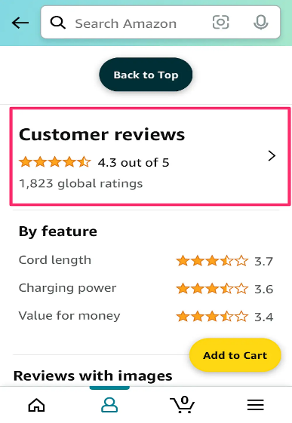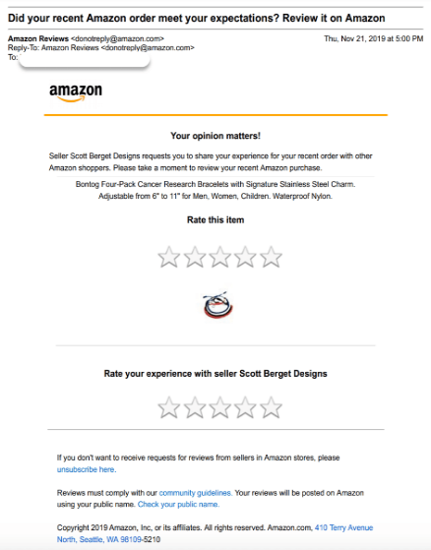

Similar to this, kids and their parents research colleges and universities in depth when looking for colleges or universities. They get in touch with relatives, friends, and family to ask about their opinions of the college. Most importantly, they scan multiple social media platforms for reviews and remarks from other users. They consider the various viewpoints and ideas of the people that are present and work to comprehend the advantages and disadvantages of each university.

As a result, an institution's status or reputation for quality is often more significant because it influences prospective students' selections when applying there. Students are keen on receiving an outstanding educational experience; thus, it is crucial to make sure they and their parents have all the details about the college's reputation.

